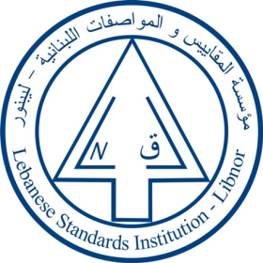
The Lebanese Standards Institution
Invites you to attend the

“Fundamentals of Project Management”
Training course
Offered by LIBNOR training centre

Date: 23-24 November 2017 Time: 9:00 A.M. Till 16:00 P.M.
Companies are invited to contact us to register nominated candidate on
training@libnor.org

